

Export ABAP Codes to TXT Files

Technical Documentation

Change Log

|  |  |  |
| --- | --- | --- |
| 1.0 | 2017-03-21 | Technical Documentation Created |
| 1.1 | 2017-03-23 | Change Request from Customer; Based on out call: Remove Development Class from Selection Screen |
|  |  |  |
|  |  |  |
|  |  |  |
|  |  |  |

# Table of contents

1 Table of contents 2

2 Introduction 3

2.1 About this documentation 3

2.2 Summary 3

2.3 Abbreviations 3

2.4 Glossary 3

3 Project Specification 4

4 Technical Description 5

4.1 Inputs and Outputs 5

4.1.1 Input 5

4.1.2 Output 5

4.2 Program Logic 5

4.3 UML Diagram 6

5 Appendix 7

5.1 List of images 7

5.2 List of tables 7

# Introduction

## About this documentation

This document contains technical description of Export ABAP Codes to TXT Files project.

Technical documentation describes required:

* inputs and outputs input
* logic description
* all necessary objects used in the software

## Summary

|  |  |
| --- | --- |
| Application: | Export ABAP Codes to TXT Files |
| Technical documentation by: | Ladislav Rydzyk |
| Delivery To: | ABAP Academy Webinar Students |
| Summary: | Download source code of selected programs and save them into txt files |
| Creation Date: | 2017-03-23 |

## Abbreviations

Abbreviations used in this document are listed in the following table.

|  |  |
| --- | --- |
| **Abbreviation** | **Explanation** |
|  |  |
|  |  |
|  |  |

Table 1: Abbreviations

## Glossary

|  |  |
| --- | --- |
| **Term** | **Explanation** |
|  |  |
|  |  |
|  |  |

Table 2: Glossary

# Project Specification

**Project requirement from customer:**

Create program, which exports ABAP program codes into txt files.

# Technical Description

Technical information for Export ABAP Codes to TXT Files.

## Inputs and Outputs

### Input

User wants to choose from selection screen following:

* Program Names
* Path to a folder on local hard drive, where all files will be exported
* Options to turn on/off displaying success and error logs

Software should export all codes from provided program names and programs contained in provided packages.

### Output

#### Exported Files

Code from each program must be stored in separate txt file.

Files names should contain:

* System Name
* Program Name

Both names should be separated by “_”.

Example: Program called “ZAA_EXPORT_TEST” is being exported from “NSP” system. Exported file should contain following name: “NSP_ZAA_EXPORT_TEST”.

File extension should be “.abap” instead of “.txt”

Example: Final exported file should be called like this: “NSP_ZAA_EXPORT_TEST.abap”

#### Output Screen

Output screen should contain the following information per each exported program:

* Icon indicating if export has finished successfully or with error
* Program name
* Information written in text format
  + Success: “was downloaded successfully”
  + Error “was not downloaded successfuly”

Example:



Image 1: Output Screen Example

## Program Logic

Program logic is described in detail in the following UML diagram.

## UML Diagram

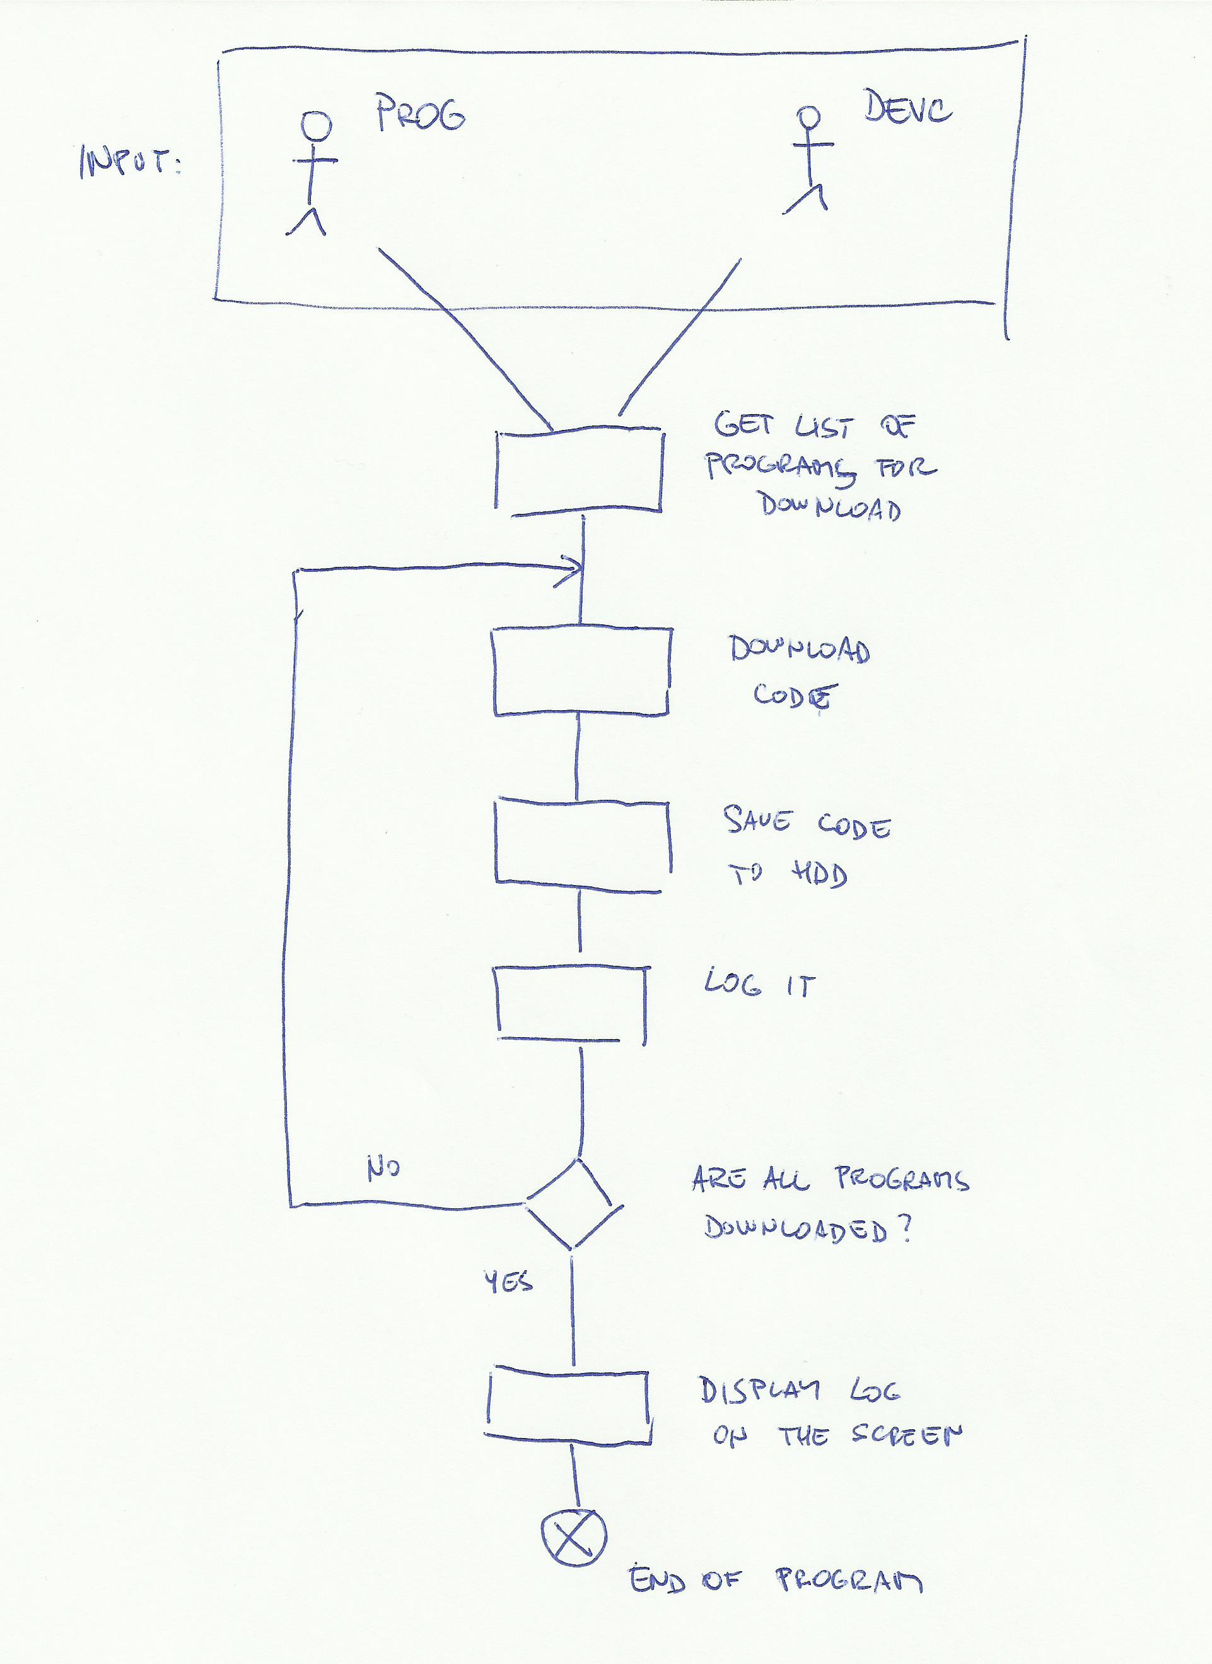

Image 2: UML diagram with solution

# Appendix

## List of images

Image 1: Output Screen Example 5

Image 2: UML diagram with solution 6

## List of tables

Table 1: Abbreviations 3

Table 2: Glossary 3